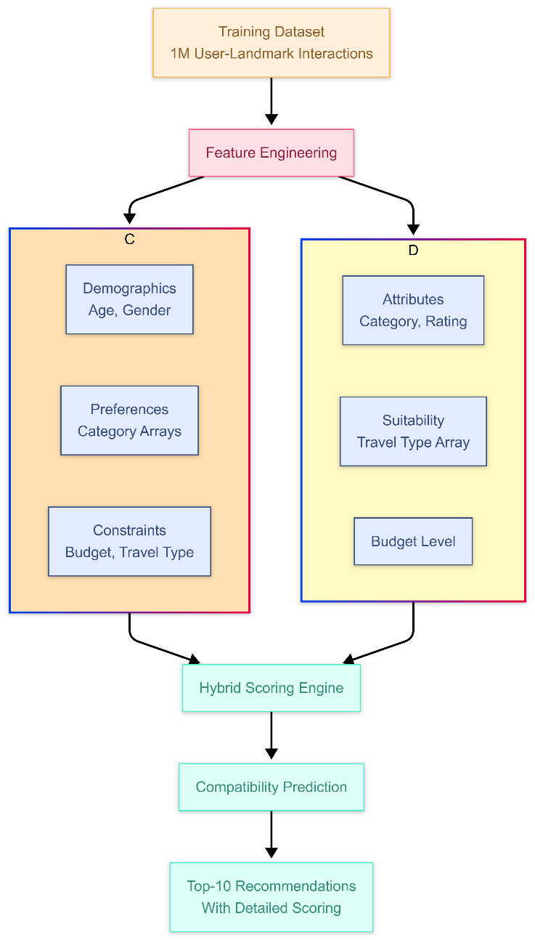

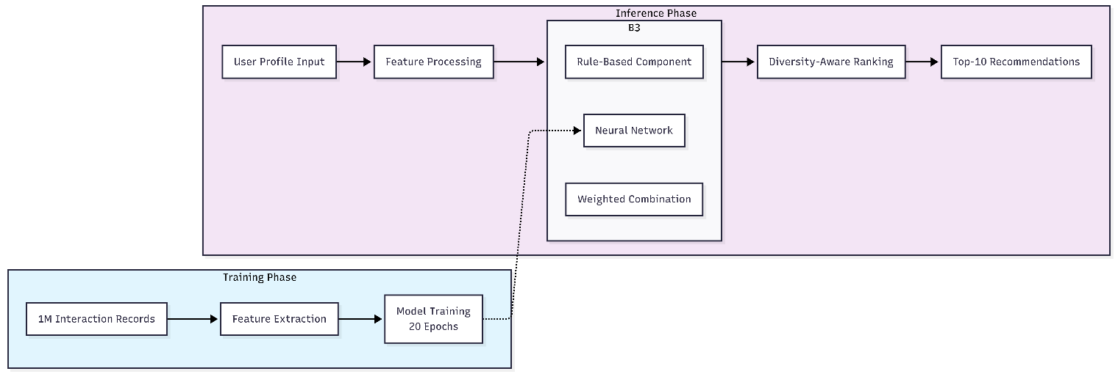

      - Data Integration and Processing
The system is trained on a comprehensive dataset consisting of one million user–landmark interaction records, each representing a compatibility evaluation between specific user attributes and landmark characteristics. The structure of this dataset directly informs the system’s processing pipeline: user features—including age, gender, budget level, travel type, and preference vectors—are extracted and normalized, while landmark features such as category, rating, budget level, and suitability vectors are processed in parallel. This structured training process enables the model to learn compatibility patterns across 438 distinct landmarks spanning ten categories, with each landmark defined by a unique combination of attributes.
During inference, new user profiles are processed through the same feature extraction and normalization pipeline used during training, ensuring consistency between training and deployment representations. The system does not rely on a separate runtime landmarks database; instead, comprehensive landmark representations are embedded within the trained model parameters. As a result, the system can generate recommendations efficiently without real-time database access, as all relevant landmark information has been encoded during training.

## Data Design

### 1. Data Gathering Process

The primary dataset used in this project consists of tourism landmarks and places located in Cairo and Giza. The data was gathered by scraping publicly available information from TripAdvisor using RapidAPI, which provides programmatic access to structured TripAdvisor endpoints. The scraping process focused on extracting relevant attributes such as landmark names, categories, ratings and tags through authenticated API requests rather than direct HTML parsing.

After data collection, a filtering stage was applied to retain only the categories relevant to the scope of the system (e.g., museums, sights & landmarks, outdoor activities, entertainment, and cultural attractions). This ensured alignment between the dataset and the project objectives, which aim to provide personalized tourism recommendations rather than a generic travel listing.

### 2. Data Sources, Sampling Methods, and Collection Tools

**Data Sources:**
The main data source is TripAdvisor, accessed through RapidAPI. RapidAPI was selected because it offers a stable, documented, and scalable interface for retrieving TripAdvisor data in a structured JSON format. This approach improves data reliability and consistency compared to traditional web scraping. The API provides essential information such as aggregated ratings, descriptive tags, and categorical classifications required for building recommendation systems.

**Sampling Methods:**
A purposive sampling approach was adopted. Instead of collecting all available tourism data, only landmarks within the geographic boundaries of Cairo and Giza were selected. Additionally, category-based filtering was applied to include only attraction types relevant to the system’s use cases. This sampling strategy reduces noise and improves the relevance of recommendations.

**Data Collection Tools:**
Python was used as the primary data collection and preprocessing tool. Data was retrieved from TripAdvisor via RapidAPI using HTTP requests, and the responses were handled in JSON format. Python libraries such as Requests were used for API communication, while Pandas was employed for data cleaning, transformation, and filtering. The processed dataset was then stored in a structured CSV format to ensure ease of use, portability, and reproducibility.

### 3. Transformation of the Information Domain into Data Structures

The information domain of the system—tourism experiences and user preferences—was transformed into structured data representations suitable for machine learning and analytics tasks.

Tourism places were modeled as **landmark entities**, each represented as a structured record containing attributes such as:

* Landmark ID
* Category (e.g., museum, outdoor activity)
* Rating
* Tags (descriptive keywords)
* Budget tier

To enable personalization, a secondary **synthetic user dataset** was generated to simulate realistic tourism behavior. Since real user interaction data was unavailable, a Python-based data generation script was designed to create artificial users and their interactions while preserving logical consistency with the landmark dataset.

Synthetic users were generated with controlled randomness to reflect realistic demographic and behavioral diversity. Each user profile includes attributes such as age group, gender, nationality, preferred attraction categories, and budget tier. These attributes were sampled within predefined ranges to ensure balanced representation and to avoid biased or extreme distributions.

User–landmark interactions were then created by linking users to landmarks that matched their preferences and budget constraints. Ratings were assigned in a semi-random manner, influenced by the landmark’s overall rating and the alignment between user preferences and landmark category. This process results in a structured user–item interaction matrix that closely resembles real-world recommendation data, while remaining fully synthetic.

This synthetic dataset plays a critical role in training and evaluating collaborative and hybrid recommendation approaches, allowing the system to model personalization behavior without relying on sensitive or unavailable real user data.

### 4. Data Storage, Organization, and Processing

**Dataset Organization:**
The data is organized into tabular structures, where each row represents a single entity or interaction. The landmark dataset contains metadata about tourism places, while the synthetic interaction dataset captures relationships between users and landmarks.

**Storage Format:**
All datasets are stored in CSV format, which allows efficient loading into Python-based data processing pipelines and compatibility with machine learning frameworks. Unique identifiers are used to link users with landmarks, ensuring data integrity.

**Processing Pipeline:**
During preprocessing, categorical attributes are encoded, numerical attributes are normalized where required, and textual tags are transformed into vector representations when used by recommendation models. The processed data is then fed into the personalized recommendation system to train and evaluate recommendation algorithms.

### 5. Dataset Description and Usage

The final dataset is composed of two main components:

1. A real-world landmark dataset extracted and filtered from TripAdvisor, representing tourism places in Cairo and Giza.
2. A synthetically generated user interaction dataset that simulates realistic user behavior and preferences.

This hybrid data design allows the system to leverage real tourism content while overcoming the cold-start and sparsity challenges commonly faced in recommendation systems. The dataset is structured, scalable, and extensible, making it suitable for both experimentation and future system enhancements.

    - System Integration and Data Flow
      - Training Data Integration
- AI Recommendation System
The system was developed using a comprehensive training dataset structured as one million records of user-landmark compatibility assessments. This dataset integration occurred during the model development phase, where the structured records were processed to extract features, normalize numerical values, and encode categorical variables. The training process leveraged the complete dataset to learn patterns across all 438 landmarks and the full range of user characteristics, with careful attention to data balancing across categories and attribute combinations. The resulting model encapsulates the knowledge derived from this training data, enabling recommendation generation without requiring access to the original dataset during deployment.
      - Inference-Time Data Processing
- AI Recommendation System
During system operation, new user profiles undergo the same feature processing pipeline used during training: age values are normalized to the 18-75 range observed in the training data; categorical variables are encoded using the same schemes established during training; preference arrays are transformed into multi-hot vectors across the ten category dimensions; and all features are assembled into the input format expected by the trained model. This consistency between training and inference data processing ensures that the model receives inputs in the same representation space it was trained on, maintaining prediction accuracy and reliability.

Figure (N)Integration Architecture

